Bahria University,

Karachi Campus



LAB EXPERIMENT NO.

**1**

LIST OF TASKS

|  |  |
| --- | --- |
| TASK NO | OBJECTIVE |
| **1** | Write a sketch to interface Arduino with LED, LED should blink with a delay of 1 second. |
| 2 | Write a sketch to interface Arduino with SPDT switch & LED |

Submitted On:

15 December 2023

____________

(Date: DD/MM/YY)

**Task 1**

Write a sketch to interface Arduino with LED, LED should blink with a delay of 1 second.

int LED = 7;

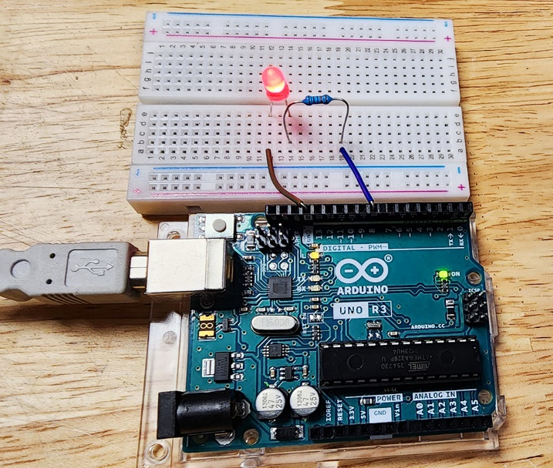void setup( )

{

pinMode(LED, OUTPUT);

}

void loop( )

{

digitalWrite(LED, HIGH);

 delay(1000);

digitalWrite(LED, LOW);

 delay(1000);

}

**Task 2**

Write a sketch to interface Arduino with SPDT switch & LED

int LED = 7;

int SW = 12;

void setup()

{

 pinMode(LED,OUTPUT);

 pinMode(SW,INPUT);

 }

 void loop()

 { int buttonstate = digitalRead(SW);

 if (buttonstate == HIGH)

 {

 digitalWrite(LED , HIGH);

 }

 else

 { digitalWrite(LED , LOW);

 }

}